a. The two alternating voltages are given by $v_{1}=15 sinωt volts and v_{2}=25\sin\left(ωt-\frac{π}{6}\right)volts.$
i. Determine a sinusoidal expression for the resultant $v_{R}=v_{1}+v_{2}$ by finding the horizontal and vertical components.
ii. Determine the resultant $v_{R}$=$v_{1}-v_{2}$ using horizontal and vertical components.

(b)Calculate the 1st and 2nd moment of area for the shape shown about the axis s-s and find the position of the centroid. ( Part of L.O. 3.1)

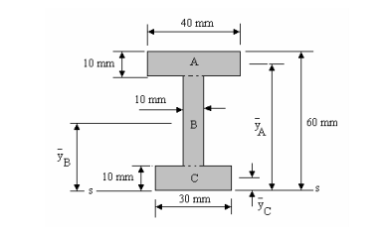

L.O. (Part of 3.1)
(c) Find the eigenvalues and eigen vectors for the matrix
$$\left(\begin{matrix}0 & 2 & 1 \\ 4 & 1 & 0 \\ 4 & 0 & 1\end{matrix}\right)$$

TASK: 5
Determine the power series solution of the differential equation:
$\frac{d^{2}y}{{dx}^{2}}+x\frac{dy}{dx}+2y=0$ Using Leibniz - Maclaurin’s method, given the boundary conditions that at
$x=0, y=1 and \frac{dy}{dx}=2$ (L.O.4: 4.4)
TASK 6:
- Determine the general power series solution of Bessel’s equation.
$$x^{2}\frac{d^{2}y}{{dx}^{2}}+x\frac{dy}{dx}+\left(x^{2}-v^{2}\right)y=0$$

(Part of D3)

- Show that the power series solution of the Bessel equation of the above problem may be written in terms of the Bessel functions $J_{v}\left(x\right) and J_{-v}\left(x\right) as:$
$${AJ}_{v}\left(x\right)+{BJ}_{-v}\left(x\right)={\left(\frac{x}{y}\right)}^{v}\left\{\frac{1}{τ(v+1)}-\frac{x^{2}}{2^{2}\left(1!\right)τ(v+2)}+\frac{x^{4}}{2^{4}\left(2!\right)τ(v+4)}- ….\right\}$$
$(part of D3)$

